# Assignment 5

Adithya Chandrashekar [ 1000990558]

Kailash Havildar[1000996588]

**Instructions to upload and download file:**

1. Uploading to the google cloud has been done through a tool called Gsutil. It is available to download on its website and also through the below command.

Sudo Pip Install gsutil

1. After installing gsutil, we found how to measure time in shell script. References to the same has been provided below.
2. Run gustil config to get your key through the website. It will authenticate you to start uploading and downloading.

gsutil config

1. The documentation of gsutil tool helps to copy the files from local host to google storage.

gsutil cp //home/adi/Desktop/100k.csv gs://assignment5-kaiadi/100k.csv

1. In order to download, use the below command.

gsutil cp //home/adi/Desktop/100k.csv gs://assignment5-kaiadi/100k.csv

**Instructions for Google sql:**

1. We have used Mysql Workbench to connect to google cloud sql. We provide the host name of the Cloud sql and the password to connect.
2. Authorize your local host to connect to the Cloud service by providing your ip address.
3. We use the below commands to create the tables and upload data to it. The code to upload to 10k table is shown.

**Creating Database:**

Create database assignment5;

**Using Database:**

use assignment5;

**Creating Table:**

create table weather10k (station varchar(100), stationname varchar(100), elevation varchar(100),

latitude varchar(100), longitude varchar(100), dateof date, mxsd varchar(100), tpcp varchar(100), tsnw varchar(100),

mntm varchar(100), twnd varchar(100));

**Uploading file:**

load data local infile '/users/kailashhavildar/Desktop/100k.csv'

INTO TABLE weather10k

fields terminated by ','

enclosed by ""

lines terminated by '\r\n'

ignore 1 lines;

**First Part: Uploading Files.**

**Screenshots:**

1. **Uploading 10k rows : 16s**

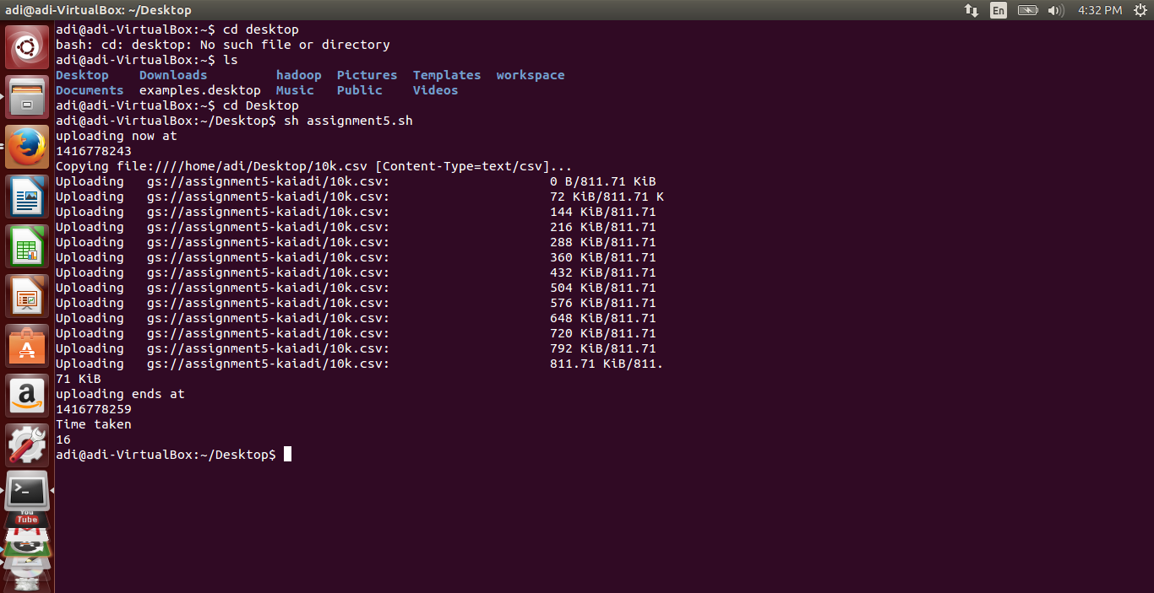

1. **Uploading 25k file:**

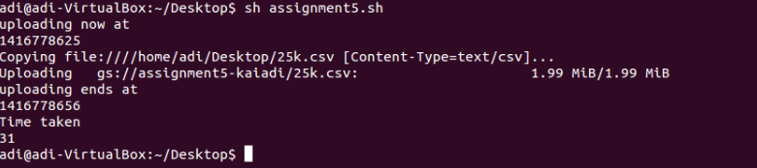

1. **Uploading 100k file:**

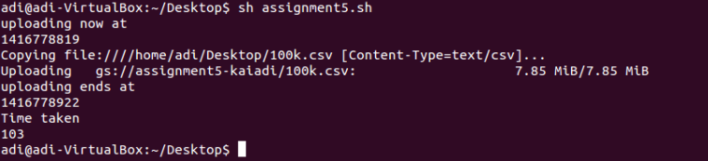

**Second Part: Downloading files.**

1. **Downloading 10k files:**

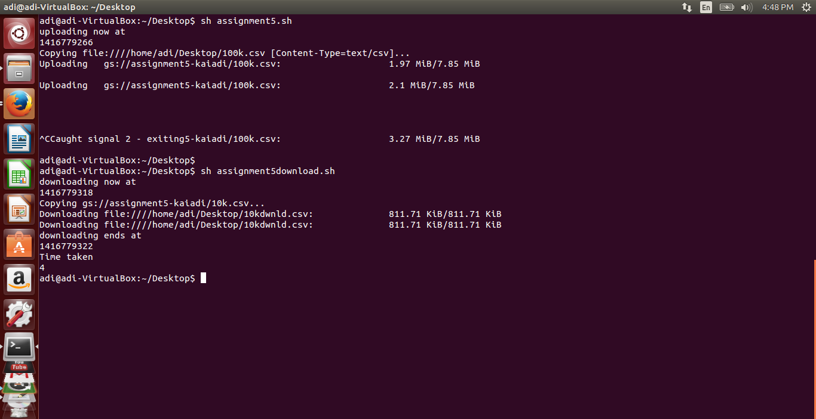

1. **Downloading 25k files:**

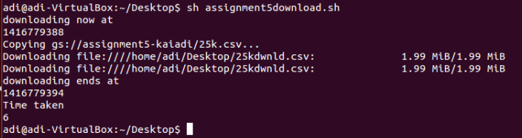

1. **Downloading 100k files:**

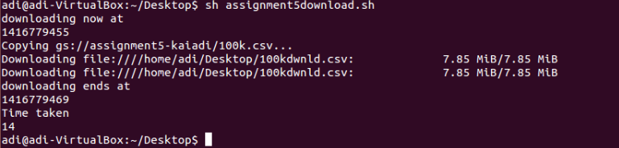

**Explaination:**

|  | **Number of rows** | **Download time [s]** |
| --- | --- | --- |
|  | **10k** | **4** |
| **Cloud Storage** | **25k** | **6** |
|  | **100k** | **14** |

The above project has been completed on a machine powered by intel i7 processor with 8gb of ram.

From the above table, it can be said that the times taken are very much asymmetrical because the download speeds are much more than the upload speeds. This is due to the fact that many internet providers provide asymmetrical internet connections which largely favor download speeds.

**Cloud SQL Screenshots:**

1. **Uploading 10k : 11.07 seconds**

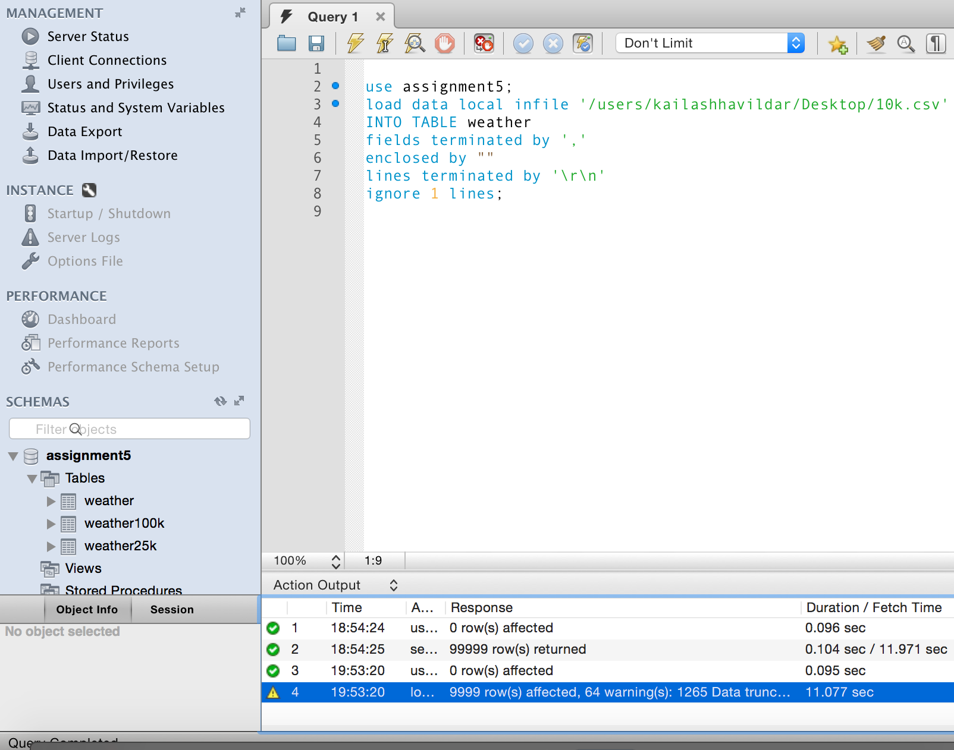

1. **Uploading 25k: 24.21s**

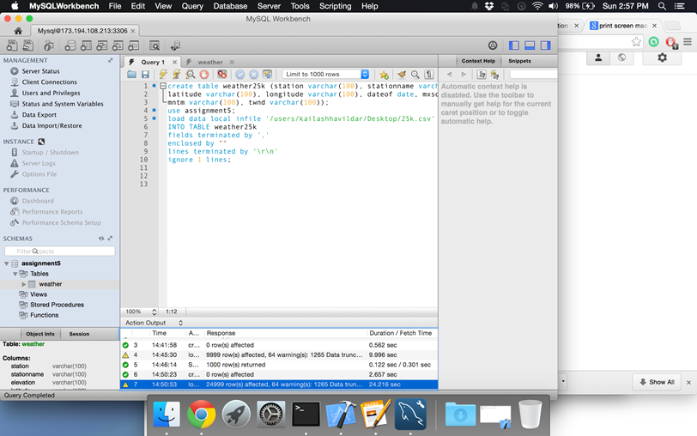

1. 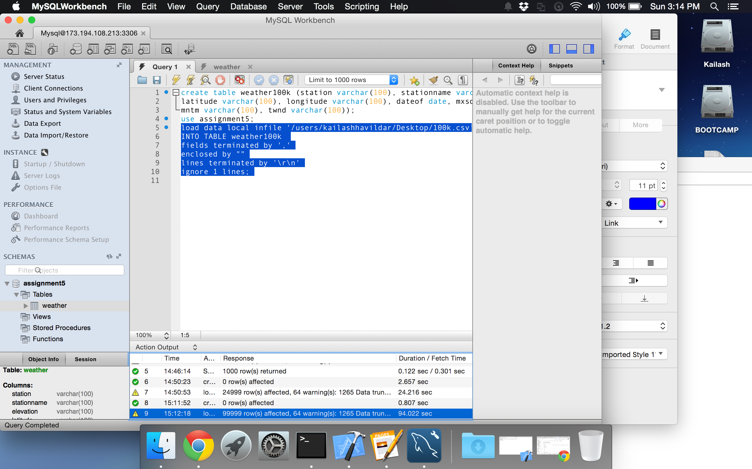 **Uploading 100k: 94.02 s**
2. 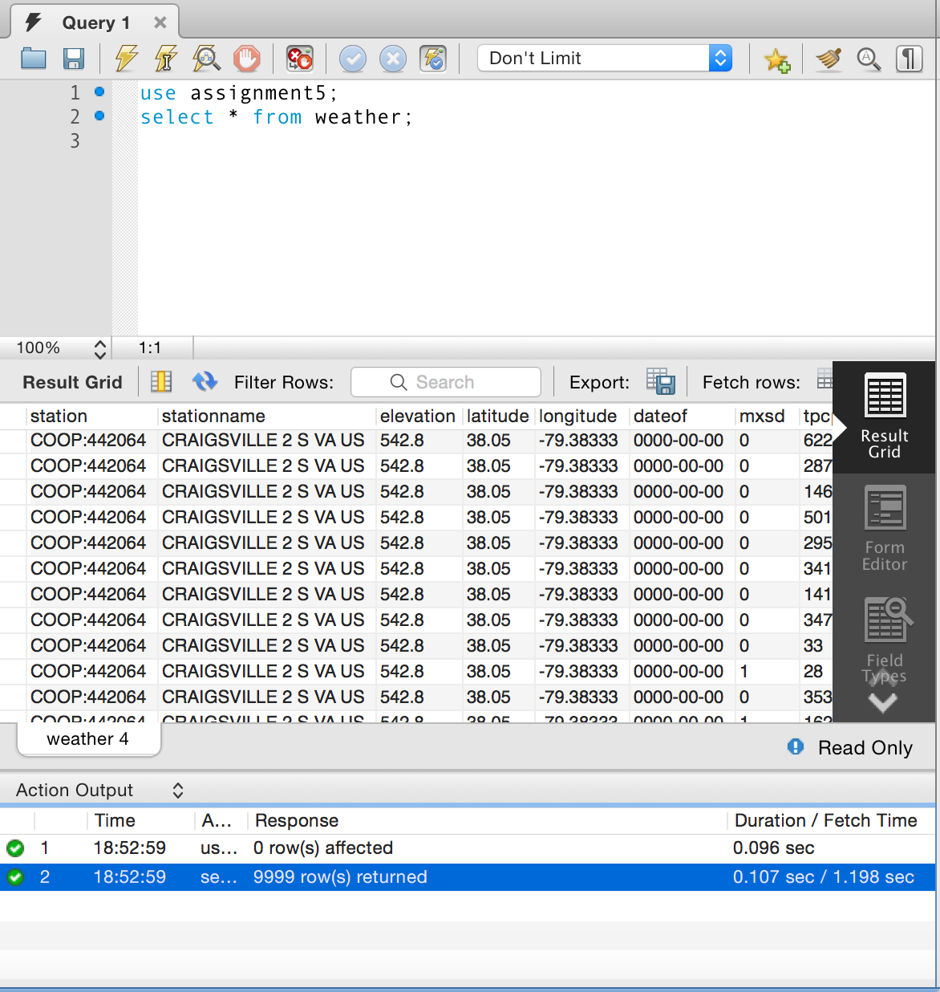**Downloading 10k :1.19s**
3. **Downloading 25k rows: 2.99 s**

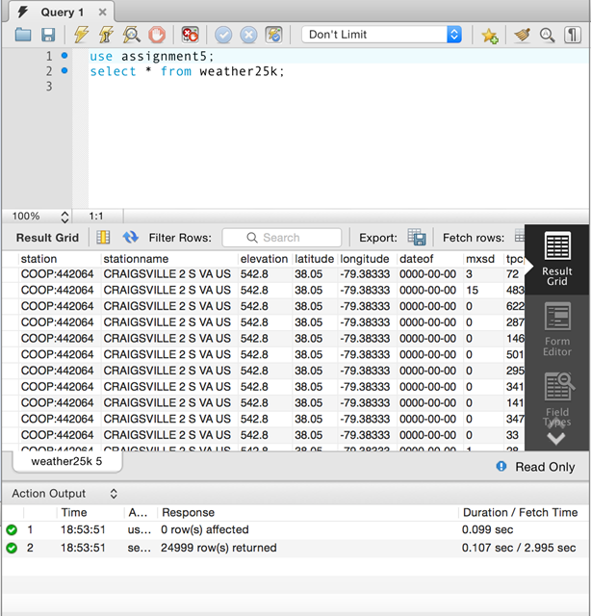

1. 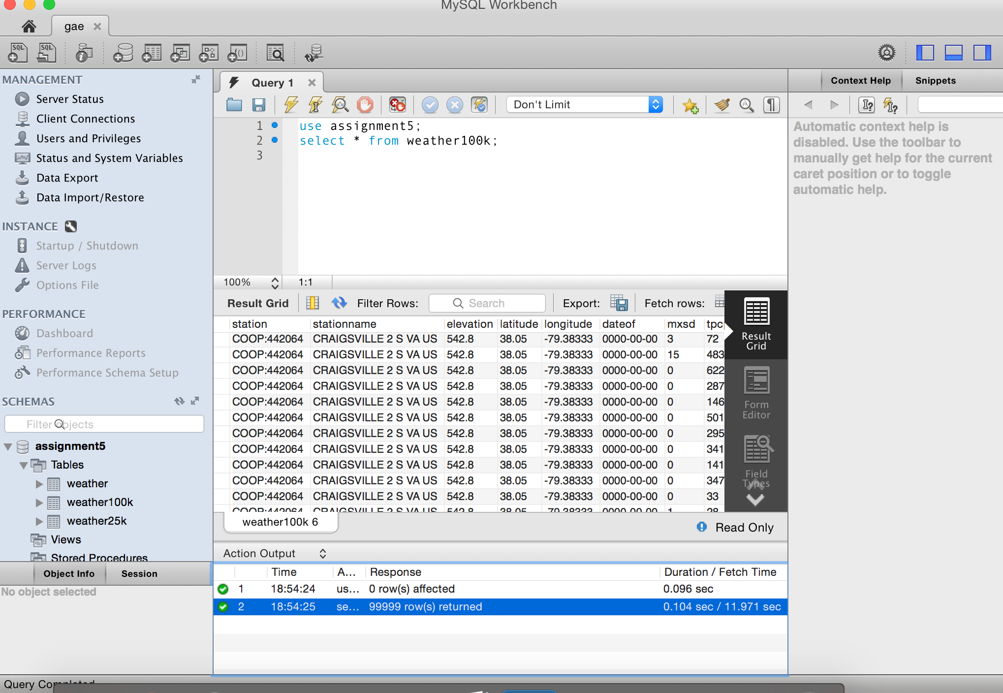**Downloading 100k rows :11.97 s**

**Time Taken:**

|  | Number of rows | Upload time [s] | Download time [s] |
| --- | --- | --- | --- |
|  | 10k | 16 | 4 |
| Cloud Storage | 25k | 31 | 6 |
|  | 100k | 103 | 14 |
|  | 10k | 11 | 1.19 |
| Cloud Database | 25k | 24 | 2.99 |
|  | 100k | 94 | 11.97 |

The above project has been completed on a machine powered by intel i7 processor with 8gb of ram.

From the above table, it can be said that the times taken are very much asymmetrical because the download speeds are much more than the upload speeds. This is due to the fact that many internet providers provide asymmetrical internet connections which largely favor download speeds.

## References:

<http://www.cyberciti.biz/faq/shell-script-to-get-the-time-difference/>

<http://stackoverflow.com/questions/8903239/how-to-calculate-time-difference-in-bash-script>

<https://cloud.google.com/storage/docs/gsutil/commands/cp>

<https://cloud.google.com/storage/docs/gsutil>

<https://cloud.google.com/storage/docs/gettingstarted-gsutil>

<http://www.youtube.com/watch?v=_kQXgjIfLgo>